Climate scenario selection (6th July 2012)
Original GCM Number | GCM number in this description | GCM title, modelling group and country
 | 1 | Baseline climate series. NOT A GCM
1 | 2 | CCCMA T47 Canadian Climate Centre, Canada
2 | 3 | CCCMA T63 Canadian Climate Centre, Canada
3 | 4 | CNRM Meteo-France, France
4 | 5 | CSIRO-MK3.0 CSIRO, Australia
5 | 6 | GFDL 2.0 Geophysical Fluid, Dynamics Lab, USA
6 | 7 | GISS-AOM NASA/Goddard Institute for Space Studies, USA
7 | 8 | IAP LASG/Institute of Atmospheric Physics, China
8 | 9 | INMCM Institute of Numerical Mathematics, Russia
9 | 10 | IPSL Institute Pierre Simon Laplace, France
10 | 11 | MIROC-M Centre for Climate Research, Japan
11 | 12 | MIUB Meteorological Institute of the University of Bonn, Germany & Meteorological Research Institute of KMA, Korea
12 | 13 | MPI-ECHAM5 Max Planck Institute for Meteorology DKRZ, Germany
13 | 14 | MRI Meteorological Research Institute, Japan
14 | 15 | NCAR-CCSM National Center for Atmospheric Research, USA
15 | 16 | NCAR-PCM1 National Center for Atmospheric Research, USA

- Barry ran the CMD module of the iHACRES model using three f values as inputs (Run 1: 0.8, Run 2: 0.6 (equivalent to grass), Run 3 f = 1.0 (equivalent to Forested)). The output from his runs were the effective rainfall and the catchment moisture deficit for each of the 12 catchments/gauges, for each of the GCM models plus the baseline historical data (labeled GCM1).
- I plotted the mean annual effective rainfall for each gauge, and for each GCM to see which models gave the wetter and drier predictions. The figure below shows the mean annual effective rainfall for each gauge and GCM model, and shows that generally GCM4 & 10 were the driest, and GCM 11 & 12 were the wettest. Similar results were seen for the other f values (i.e. 1.0 and 0.6), with there being less variation in the CMD between models.
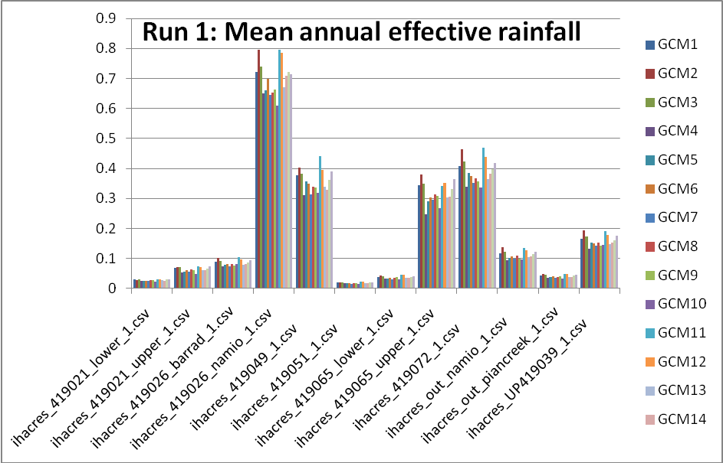

- I then plotted the percentile outputs for the effective rainfall for each gauge and each f value (ie. runs 1, 2 and 3), and found that generally GCM 11 gave the wetter curve and GCM10 the drier (see figure below for example).

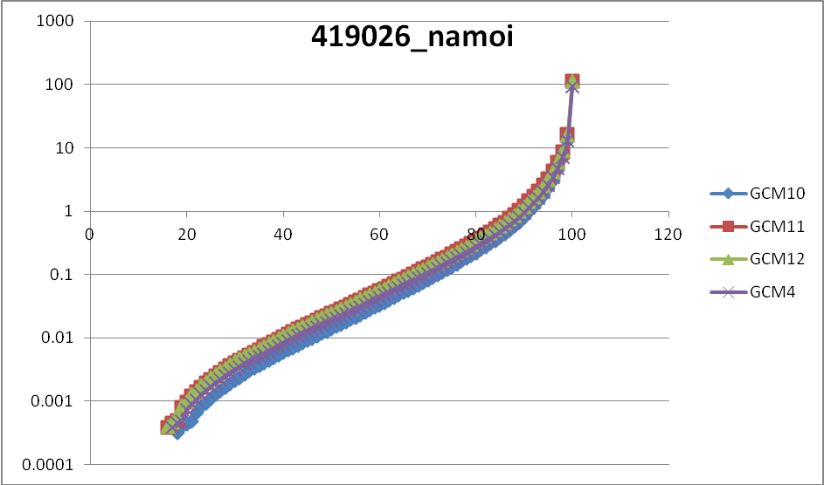

- From this I concluded to use GCM 10 as the drier and 11 as the wetter and then tried to see just how different they are from the base historical data.
- The figure below shows that there is not a great deal of difference between the baseline and the gcm models for this, the monthly rainfall for gauge location 419026_namoi.
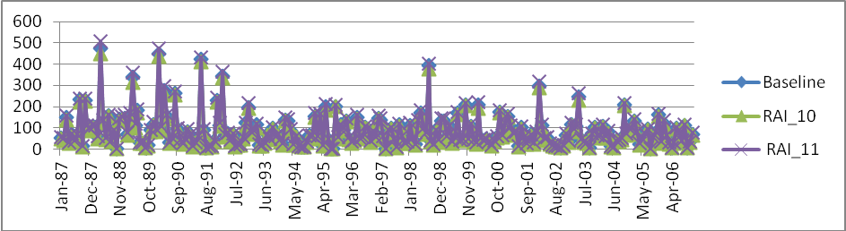
- Or for this, the monthly rainfall – PET for the same gauge
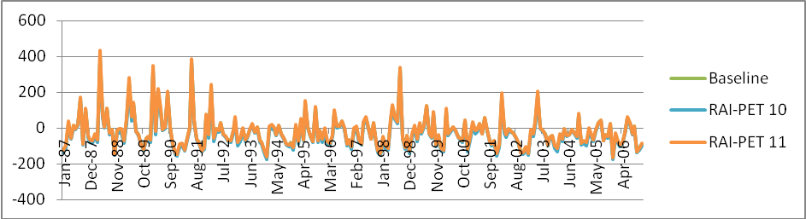

- I then compared the seasonal values of rainfall – PET and compared these to the baseline case just seeing how much change there is. An example figure is given below for 419026_namoi. It shows that GCM 10 is notably drier than the baseline in Summer, Autumn, Winter and Spring. And that GCM 11 is wetter in Summer and Autumn, but is pretty much the same as the baseline case for Winter and Spring.
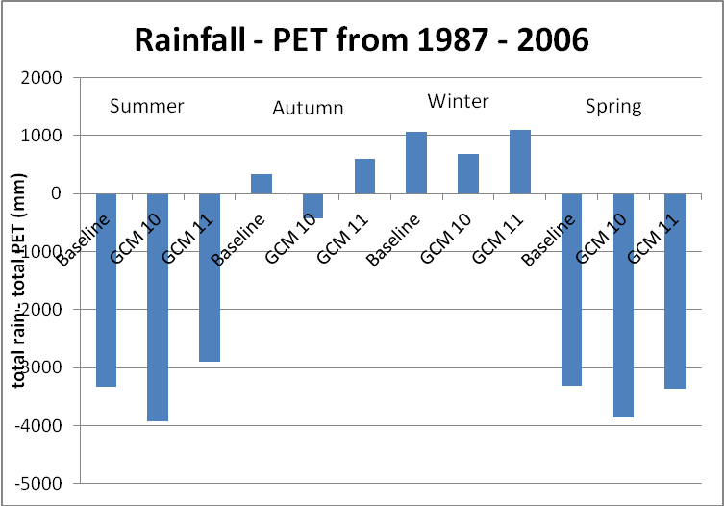
- I next did a table of the percent differences between GCM 10 and the baseline and GCM11 and the baseline for each gauge and these are given in the table and figure below.
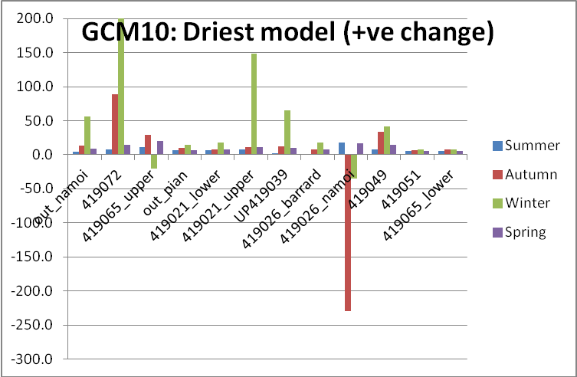
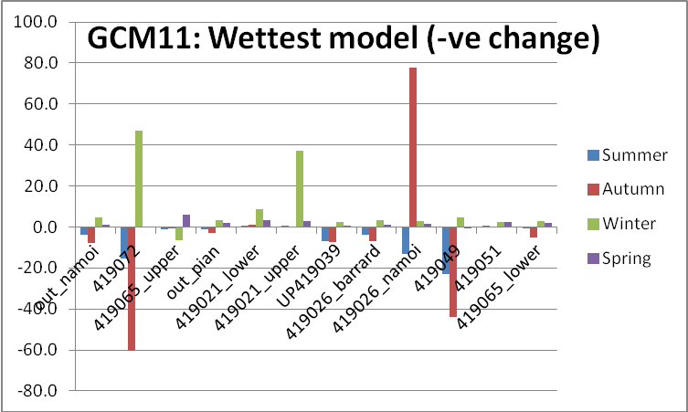
The grey boxes are those that changed less than 5% from the baseline cases. The red and green boxes are quite large changes in
 | Summer Rain - PET |  |  | Autumn Rain - PET |  |  | Winter Rain - PET |  |  | Spring Rain - PET
Gauge | Baseline | GCM10 | GCM11 | Baseline | GCM10 | GCM11 | Baseline | GCM10 | GCM11 | Baseline | GCM10 | GCM11
out_namoi | -7187.9 | 4.8 | -3.6 | -3014.6 | 13.9 | -7.7 | -439.2 | 55.9 | 4.6 | -4950.8 | 8.5 | 1.1
419072 | -3485.7 | 8.0 | -15.4 | -588.0 | 89.0 | -60.2 | -0.9 | 40268.1 | 46.8 | -3467.1 | 14.4 | -0.1
419065_upper | -5886.0 | 11.0 | -1.3 | -1719.7 | 29.1 | -0.9 | 1620.2 | -20.1 | -6.5 | -2932.1 | 19.7 | 6.1
out_pian | -9210.6 | 6.2 | -1.0 | -4202.5 | 9.9 | -2.9 | -1467.7 | 14.9 | 3.4 | -6512.3 | 6.8 | 2.0
419021_lower | -9534.0 | 6.1 | 0.7 | -4399.0 | 7.8 | 1.2 | -1250.5 | 17.9 | 8.5 | -6253.4 | 7.9 | 3.4
419021_upper | -8895.2 | 8.1 | 0.1 | -3650.4 | 11.7 | -0.4 | -192.1 | 148.4 | 37.3 | -5329.1 | 11.0 | 2.9
UP419039 | -5669.1 | 2.2 | -6.8 | -3014.8 | 12.0 | -7.4 | -396.1 | 64.8 | 2.4 | -4300.7 | 9.9 | 0.5
419026_barrard | -7592.0 | 0.7 | -4.0 | -3964.6 | 7.8 | -7.0 | -1586.7 | 17.6 | 3.1 | -6194.4 | 8.3 | 1.0
419026_namoi | -3327.5 | 18.0 | -13.0 | 336.1 | -229.2 | 77.9 | 1063.1 | -35.5 | 2.7 | -3306.3 | 16.7 | 1.5
419049 | -2631.1 | 7.9 | -23.0 | -1000.0 | 33.1 | -43.8 | -912.5 | 41.7 | 4.6 | -3947.9 | 15.0 | -0.6
419051 | -10067.4 | 5.1 | 0.1 | -5106.3 | 6.5 | -0.4 | -2133.2 | 7.3 | 2.4 | -7241.6 | 5.6 | 2.3
419065_lower | -9744.7 | 5.1 | -0.8 | -4511.3 | 8.1 | -5.0 | -2434.5 | 7.8 | 3.0 | -7499.0 | 5.8 | 1.9

So in 63% of cases the rainfall – PET varies by more than 5% (either wetter or drier). But for GCM model 10 93% of cases vary by more than 5 % from the baseline case (i.e. drier), and for GCM 11 only 33% vary from the baseline by more than 5%.
I would therefore suggest that we start with just one climate scenario, using GCM 10 (IPSL Institute Pierre Simon Laplace, France) varying from the current climate baseline (1987-2006), unless anyone objects too much. The lack in change is quite possibly due to the short time between now and 2030.

